**Werkblad Toneelmachinerieën.**

**Opdracht :** Geef bij onderstaande tekeningen de werking aan van de geschetste constructie

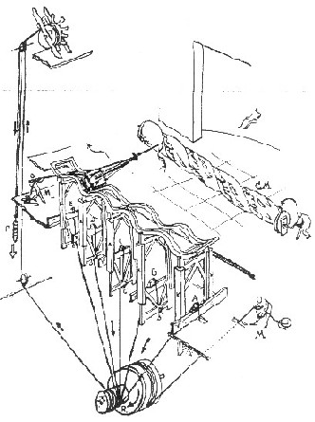1

..........................................................................................................................................................

..........................................................................................................................................................

..........................................................................................................................................................

..........................................................................................................................................................

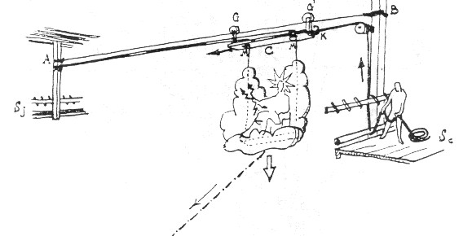2

..........................................................................................................................................................

..........................................................................................................................................................

..........................................................................................................................................................

..........................................................................................................................................................

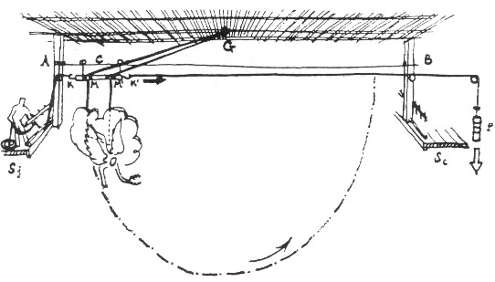3

..........................................................................................................................................................

..........................................................................................................................................................

..........................................................................................................................................................

..........................................................................................................................................................

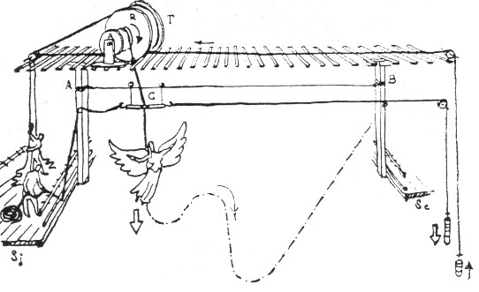4

..........................................................................................................................................................

..........................................................................................................................................................

..........................................................................................................................................................

..........................................................................................................................................................

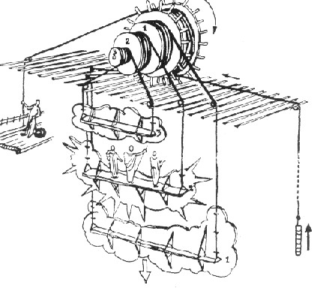5

..........................................................................................................................................................

..........................................................................................................................................................

..........................................................................................................................................................

..........................................................................................................................................................

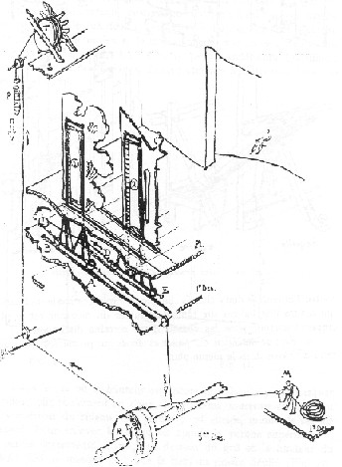6

..........................................................................................................................................................

..........................................................................................................................................................

..........................................................................................................................................................

..........................................................................................................................................................